**INHERITANCE, ABSTRACT, AND INTERFACE**

**PEMROGRAMAN BERORIENTASI OBJEK**

*Laporan ini disusun untuk memenuhi tugas mata kuliah Praktikum Pemrograman Berorientasi Objek*

**

Disusun oleh:

Nurul Anisah 211511052

**PROGRAM STUDI D3 TEKNIK INFORMATIKA**

**JURUSAN TEKNIK KOMPUTER DAN INFORMATIKA**

**POLITEKNIK NEGERI BANDUNG**

**2022**

Exercise 1 : The Circle and Cylinder Classes

* [Task 1.1] Modify class Circle

Modify class Circle,

1. variable color : string

2. Constructor Circle(radius : double, color : string)

3. Getter and setter for color You can reuse the Circle class above.

Jawaban :

* [Task 1.2] Overriding the getArea() method

Method Overriding and "Super": The subclass Cylinder inherits getArea() method from its superclass Circle. Try overriding the getArea() method in the subclass Cylinder to compute the surface area (=2π×radius×height + 2×base-area) of the cylinder instead of base area. That is, if getArea() is called by a Circle instance, it returns the area. If getArea() is called by a Cylinder instance, it returns the surface area of the cylinder. If you override the getArea() in the subclass Cylinder, the getVolume() no longer works. This is because the getVolume() uses the overridden getArea() method found in the same class. (Java runtime will search the superclass only if it cannot locate the method in this class). Fix the getVolume().

After overridding the getArea() in subclass Cylinder, you can choose to invoke the getArea() of the superclass Circle by calling super.getArea().  
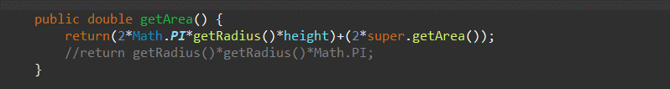



* [Task 1.3] Provide a toString() method

Provide a toString() method to the Cylinder class, which overrides the toString() inherited from the superclass Circle, e.g., Try out the toString() method in TestCylinder.

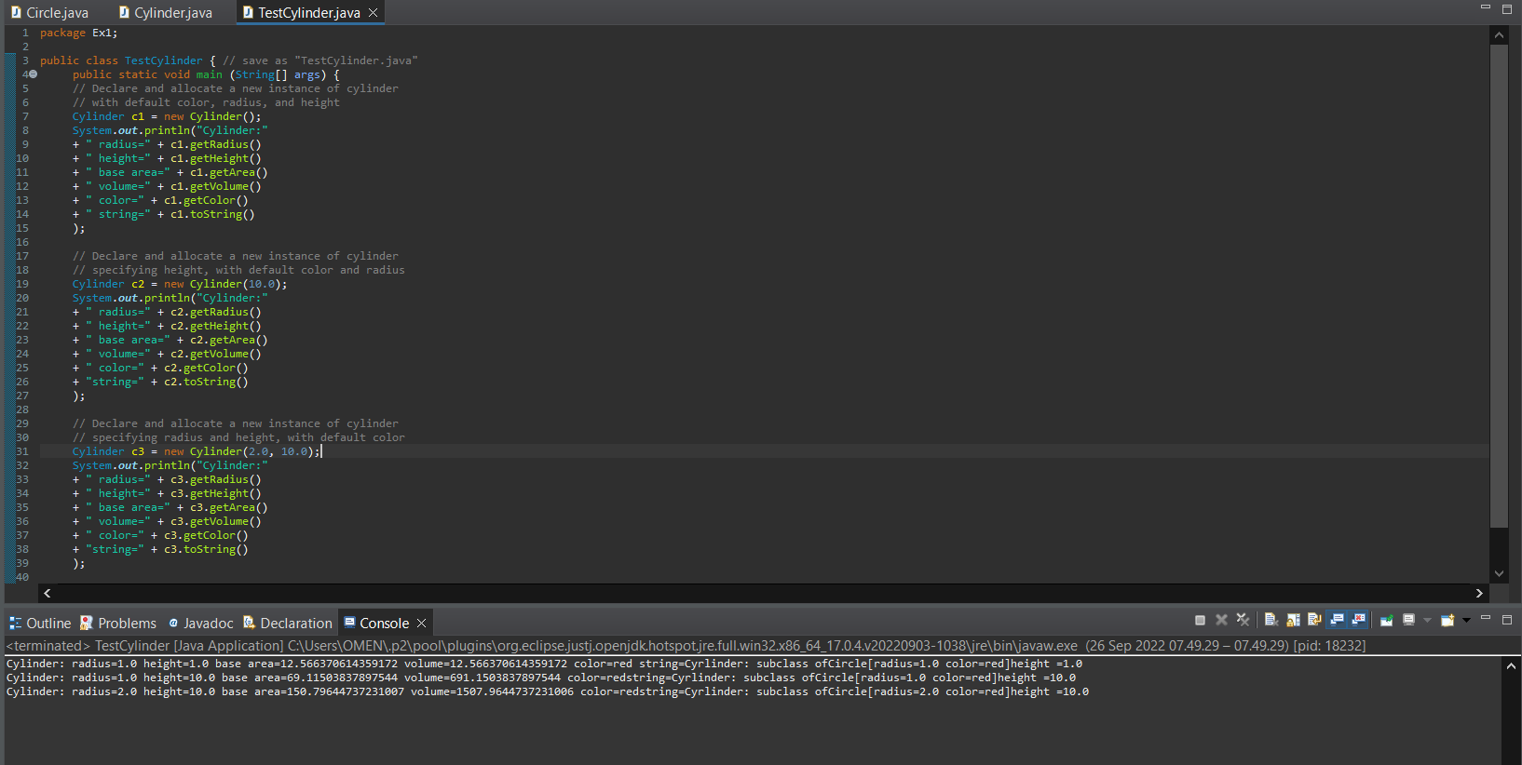

Exercise 2 : Superclass Shape and its Subclasses Circle, Rectangle and Square

[Task 2.1]